**Metric Choice**

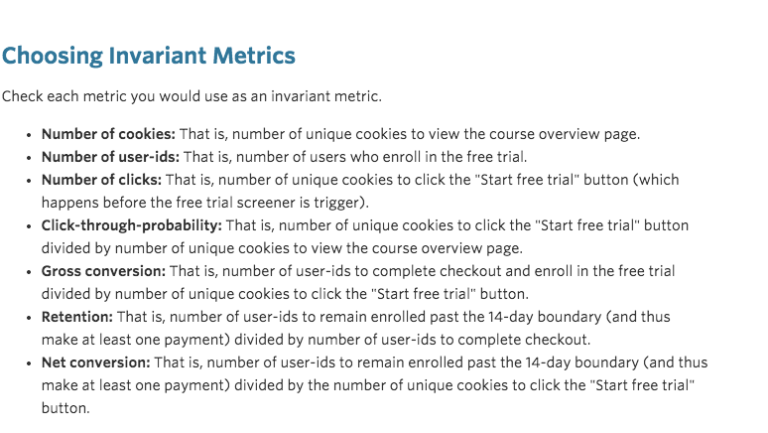

Invariant Metrics: number of cookies, number of clicks

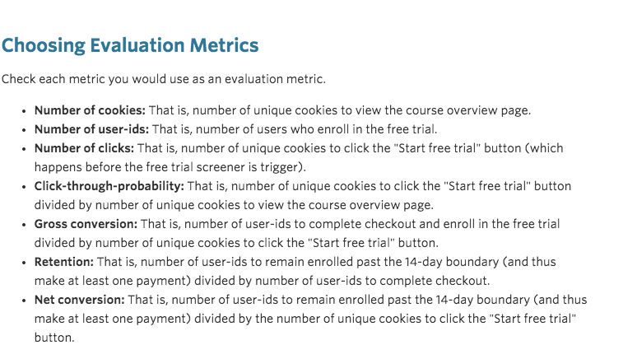

Evaluation Metrics: Gross conversion, (Retention), Net conversion

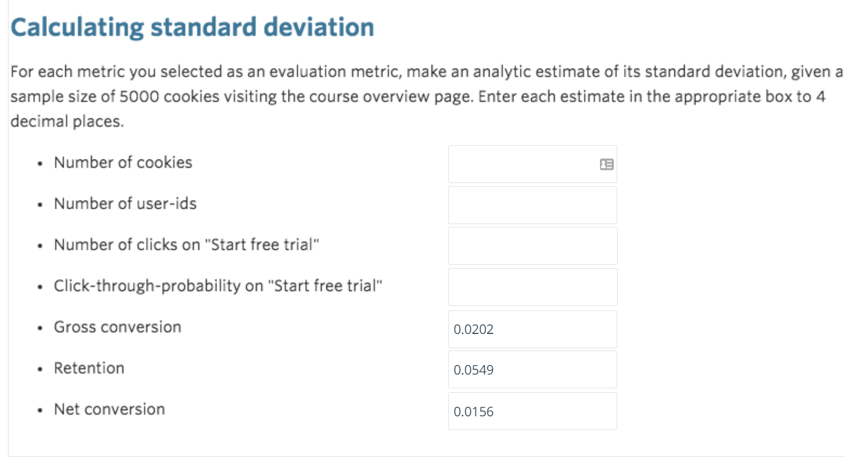

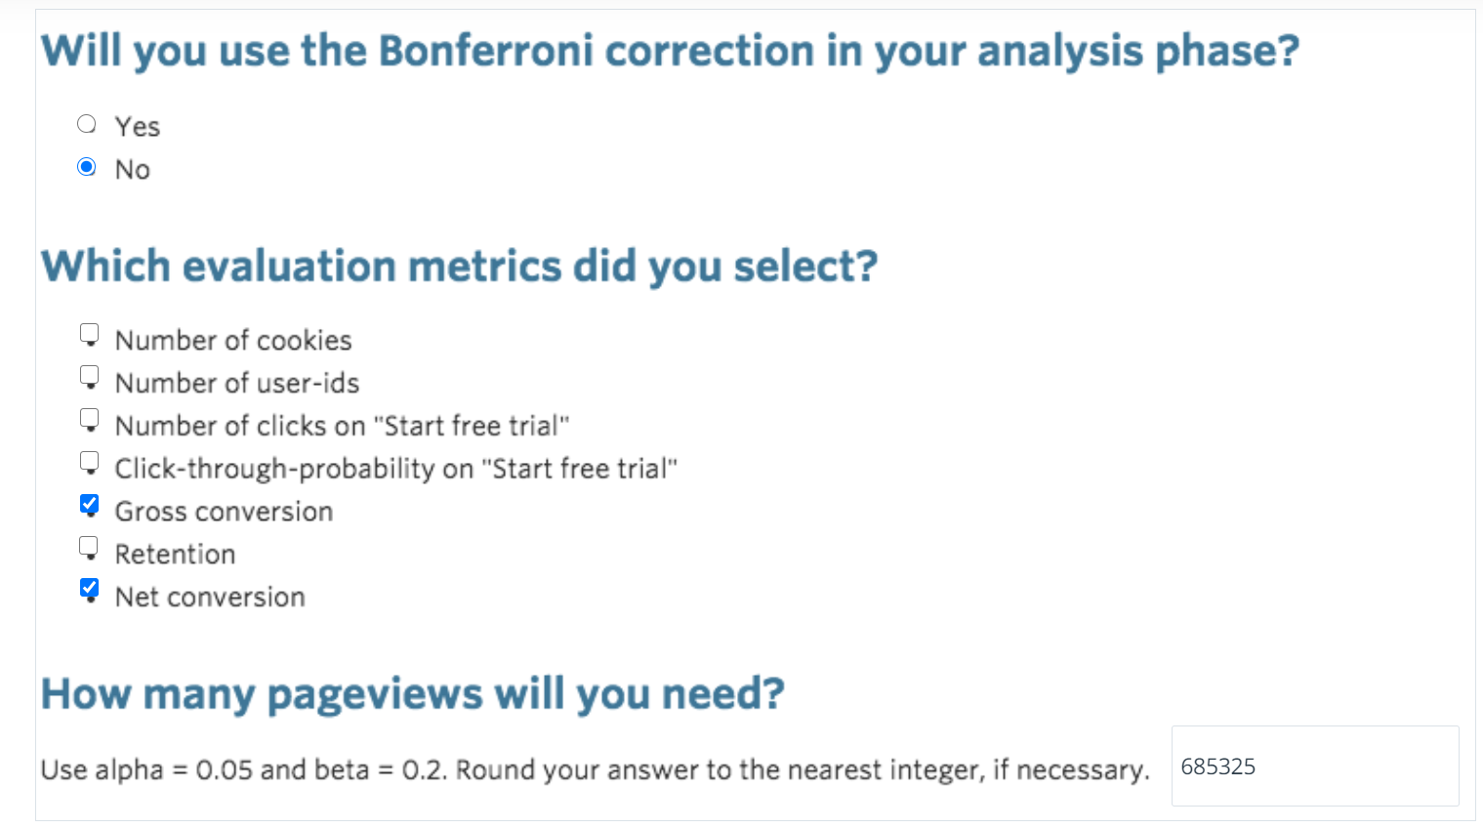

As we now have more than one hypothesis, the chance to get false positives increases. However, our metrics are not fully independent which is why the true probability for false positives will still be lower than 9.75% (that's the case for independent metrics). We could then use family-wise error rate such as Bonferroni or false discovery rate methods to account for the multiple hypotheses problem. However, they have flaws as well (e.g. we could easily end up with more false negatives; see here and here). Hence, given that the chance to get more false positives is only slightly increased in this case, we won't control for multiple hypothesis here.

